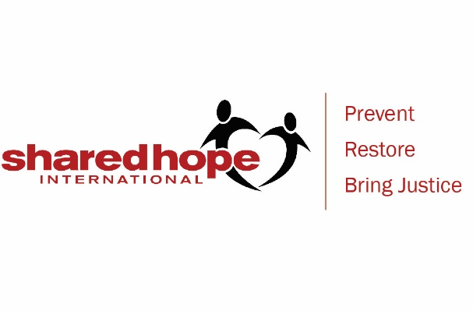
Dear Administrators, Teachers and Staff,
We welcome (SPEAKER’S FULL NAME) with Shared Hope International to share with us about online safety on (DATE/TIME) at (SCHOOL NAME).
(SPEAKER’S FIRST NAME) is introducing information from Shared Hope and other organizations using age-appropriate activities to educate and equip our students about being safe and smart in their digital world.
Our discussion of online safety covers:
- Why it’s important to keep private information private, and not allow someone we don’t know on our sites, both social media and gaming.

- How to recognize online predators, talk about online and in-person exploitation and sexual exploitation.

- The consequences of sexting or “nudes” - for both sending and receiving compromising photos.

- How “sextortion” can lead to hopelessness and potentially to teen suicide, which is sadly becoming more common.

- How to set boundaries, what to do if you’ve crossed some lines.

- How to handle it if someone is making you uncomfortable or asking for inappropriate content.

Language such as “rape”, “sex buyer”, “minor sex trafficking”, “suicide” and “pornography” will possibly be used as we discuss this topic.
An informational letter is being sent home with each student for the presentation at (SCHOOL NAME) on (DATE/TIME) by (SPEAKER’S NAME), a trained volunteer from Shared Hope International.
Questions may be directed to (SCHOOL OFFICIAL NAME/ CONTACT INFO)
Sincerely,
(SCHOOL OFFICIAL NAME)

Jo Lembo, Director of Faith Initiatives and National Outreach, introduction to the new Chosen. Stop Predators. product
Jennifer Reid, Manager Growth Strategies & Events
Chosen. Stop Predators. Film viewing
Group Discussion: (Jo facilitate)
Feedback on the film
Feedback on accompanying documents
SHI goals for distribution
Where are the homeschool audiences who need this product?
How can we best reach the homeschool audiences in this area?
Thank you for your time and invaluable input!

