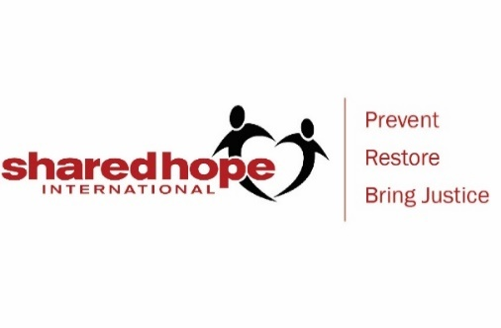
Dear Parents,

On __(date)__________________________at ______________,
Shared Hope International will be presenting to our middle school students on the topic of Internet Safety.

Internet Safety presentations to middle schools introduce information with age-appropriate activities to educate and equip our students about being safe and smart in their online activities. Language such as reference to predator’s tactics online, traffickers grooming process, recognizing fake online profiles, technology dangers, signs to know if someone is being exploited, and discussion of natural vulnerabilities from how we are wired as humans, will be used in our discussion of this topic.

Our discussion of internet safety includes:

- How to protect yourself
  - The importance of keeping private information private, and not allowing someone we don’t know on our sites, both social media apps and gaming.
  - Guard your feelings and discuss emotions only with people you personally know and trust
  - Don’t talk to someone you don’t know in real life
  - Identify a safe adult that you can go to if you need help at school, church, away from home
- How to recognize online predators, talking about online and in-person exploitation and grooming.
  - How a fraudulent relationship builds trust, requires secrets, separates you from safe people, controls, hides their true identity, creates dependency
- Clarify what is sexting and what could happen if you send compromising photos to someone, even a friend.
- We help students learn how to set boundaries
  - What to do if you’ve crossed some lines, or if someone persistent in wanting to communicate with you, is asking questions or pushing for response
  - How to report someone who makes you uncomfortable online
- Signs to watch for if you think a friend might be in trouble and what to do to protect them
- Referral to website for students Youthonline.sharedhope.org

Our goal is not to scare students, but to equip them with knowledge and tools to protect themselves and protect their peers, as well as learning how to be a responsible citizen in the online world.

Sincerely,

Jo Lembo, Director of Faith Initiatives & National Outreach
O) 360-860-6095
Jo@sharedhope.org

